Usage: ./nexus {start|stop|run|run-redirect|status|restart|force-reload}

**Sonatype nexus remote repository:**

* After installing nexus 2.14.8, go to bin directory and open cmd. Then type **nexus.bat console**. It starts the nexus server
* Internally it uses small app called jetty. Jetty is also web server
* Typically, nexus runs on an ip “**netstat -na | findstr 8081**” is the port. Use this command even in Linux as well
* **Netstat -an | grep 8081 -🡪 to check on linux**
* **Localhost:8081/nexus**

By default, we can login with admin/admin123

We can change the password as below

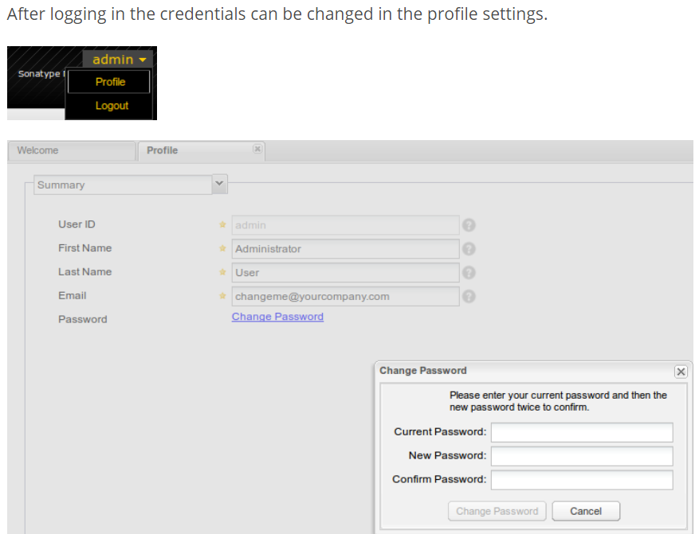

* We can also create users as below under security settings.

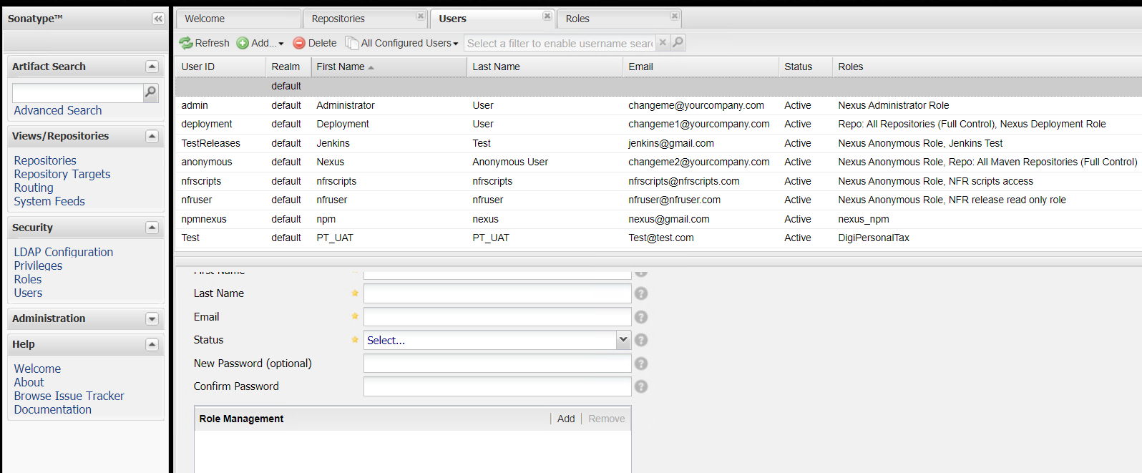

**Types of repositories:**

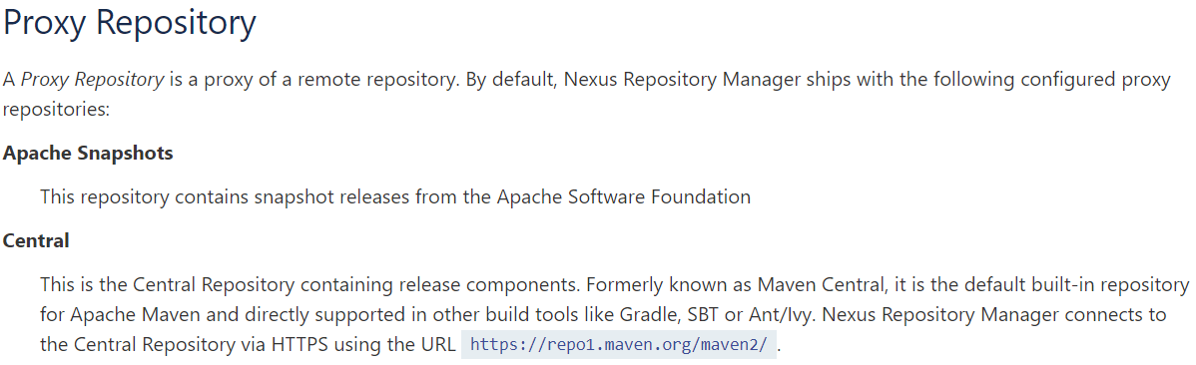

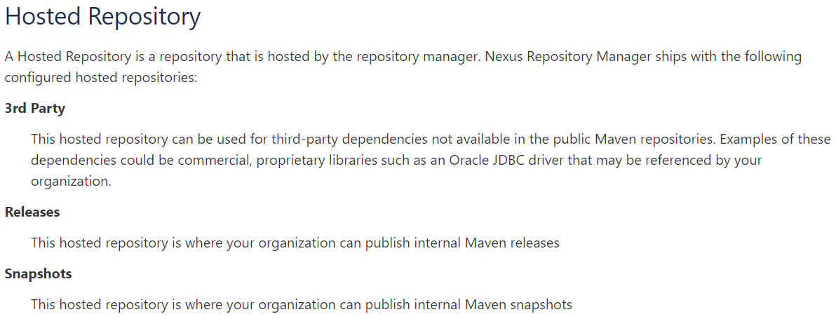

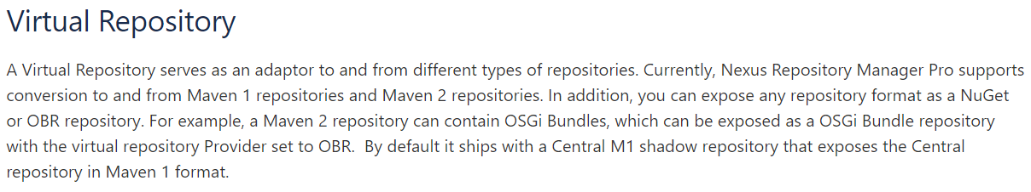

**Creating repository:**

* Go to nexus repository manager. Create a hosted repository as below

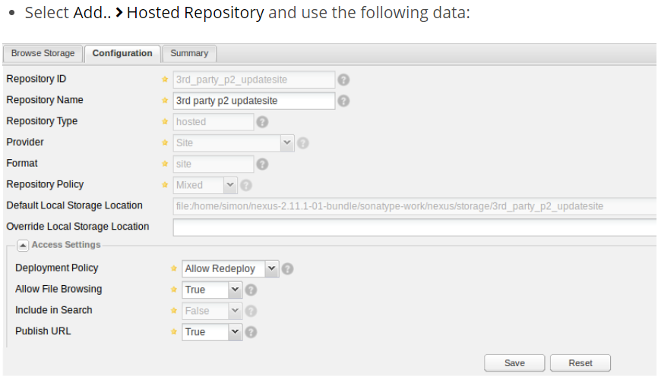

* If we want, we can override default local storage location or else it will take the nexus installation directory as above
* Once the version is released, if we want to overwrite that, we need to give allow redeploy like snapshot versions. Otherwise, we need to give disable redeploy
* Below is the error we get when we redeploy on release repo

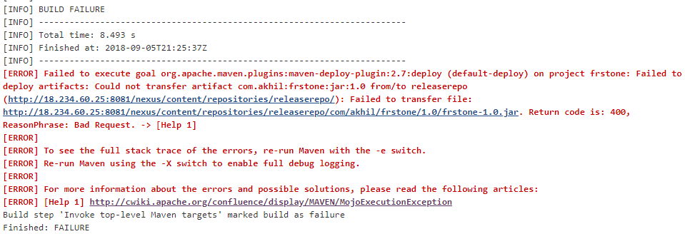

once repository is created, we can see the repo URL/path as below.

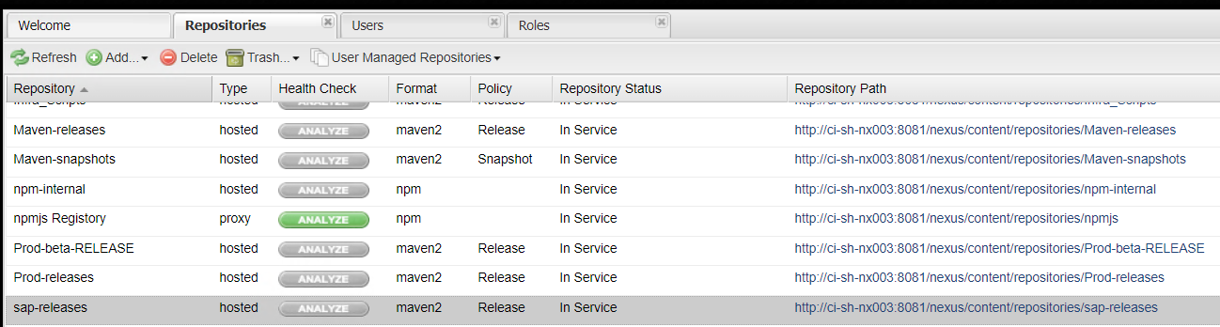

We can also browse the content in repo using those URLs